*Parkinson’s and Alzheimer’s disease detection using CNN-CAM algorithm*

**Dr. D Jeya Mala**

**Amisha Tripathi**

**Saloni Ghule**

*Abstract*— Parkinson's disease (PD) governs one's brain and is a brain disorder that is apparent all over the world. It is known to many reports that, worldwide, the number of people affected by Parkinson's disease is indeed 10 million which is statistically 0.3% of the whole population (El-Bakly ,L Lear et al.,2019). Evidence from biomedical research is that the Alzheimer’s disease is a neurodegenerative disease. Most commonly among dementias, worsening memory and the lack of coordination are the most telling signs of Alzheimer’s. The carcinoma adversely affects the patient’s ability to attain non-invasive therapy. It is known only when this disease gets to its advanced level of no treatment effectiveness. In the model that we are proposing identify of the disease will be curable at its inception stage, so it can be predicted by the record so we are going to take some data from the clinic for this purpose .This type of treatment option can be useful for the patients in getting better as they will be diagnosed and treated in the early stage of the disease. As a conclusion of this research project these symptoms will reveal whether or not a person is suffering from Parkinson disease; while in Alzheimer's illness, it will say what class of symptom is Non-Demented, Very Mild Demented, Mild Demented, Moderately Demented present in the MRI scan of a human. To correctly analyze the stages for the parkinson’s disease, model with more accurate predictions among the other evaluative models is selected and used. Thus ,CNN model combined with CAM was utilized for the classification of images for prediction of Alzeimer’s class as well.

Keywords—Linear Regression, Support Vector Machine, Convolutional Neural network ,Random Forest,Decision Tree, Naive Bayes, K nearest Neighbour

# Introduction

The substantia nigra is the part of the midbrain where dopaminergic neurons in Parkinson’s disease die. Patients will Parkinson’s disease (PD) can experience dysarthria,motor speech system weakness, paralysis, and loss of coordination that effects respiration, articulation and prosody.Parkinson’s disease is frequently misdiagnosed for many years as the disease’s course and symptoms can vary.The disease get worsen with time and as more symptoms appears it becomes more challenging to treat so there is a need of new sensitive diagnostic methods.The main deficiencies of Parkinson’s speech are Loss of intensity, monotony of pitch and loudness, diminished stress, inappropriate silences, brief bursts of speech, variable tempo, incorrect consonant articulation, and a harsh and breathy voice. The variety of voice-related symptoms appears promise for a prospective screening tool.The variety of voice-related symptoms appears promise for a prospective screening tool because of the non-invasive nature of capturing voice data and the ease with which it may be done using mobile devices. Alzheimer's disease (AD) is a form of brain malfunction where the patient's mental abilities gradually worsen. Memory loss and dementia are its most evident symptoms. According to researches about 35 million individuals were affected by AD in 2010, and it's predicted that 1 in 85 people would be effected by the disease by 2050. Initially Short-term memory and learning are affected, but with time, long-term memory would also suffer. According to the findings of the scientists, Alzheimer's disease is reported to have started several years before the signs are evidently noticed. Investigators are trying to develop screening procedures that will reveal Alzheimer disease in persons who may be affected early since it is long before the pending clinical symptoms appear. Therefore, the way to prevent or at most halt the development of the condition is to find the presence of brain changes in people who are high at risk for having it. The size of such regions of brains can change and is noticeable in the studies of magnetic resonance imaging (MRI). The AD progression diagnostic with the use computing the ROIs (regions-of interest) signaling the occurrence of the atrophy and subsequent neural impairment. In most of the studies conducted so far with MRIs, only a smaller aspect of the entire brain has been observed and the large portions still unexplored with proper research. The studies usually involve analysis of ROIs with a contrasting method to detect pathology. The goal of this project was to check the possibility to separate AD and HC groups of subjects with the acceptable accuracy level if one cutting using just one pixel colour in the image is applicable.

# Literature Review

Wroge et. Al.[1] has proposed “Parkinson’s Disease Diagnosis Using Machine Learning and Voice” which depends on various machine learning algorithms to diagnose the disease using voice biomarkers. Low precision despite the evolution of machine learning algorithms, to achieve high accuracy score is difficult, as the performance of these models is obviously affected because these models are not provided with the data from doctors in hospitals. The approach to our aim of improving prediction accuracy for Parkinson’s disease, which is dependent on speech biomarkers, involves several kinds of classifiers and gene models with multiple training datasets.

Otaibi and co. [2] have come up with "a novel method of diagnosis of Parkinson’s disease with the treatment protocol". Different datasets have their particularities. The limitation of small panel of 252 patients in accuracy of machine learning algorithms comes to mind. This limitation is overcome by means of the training dataset that is different and enlarged sample size and eventually accuracy is improved.

Research proposal of Jiji et al [3], ‘the diagnosis of this disease can be made by the use of fMRI and EEG data’. The brain scans would provide the necessary information that is not readily available through the vocal modulation data putting the latter on the high cost bracket and cumbersome complexity. On the one part it is easy to utilize the voice recordings but at the same time it has the disadvantage in that it does not completely show what is happening in the mind recoding the brain scans. For instance, we can collect frequency of mood-associated words spoken by patients which can be easily done as well as that this data can be transferred without a need of brain scans therefore, logistical constraints just like these can be prevented.

Alpha et al.[4] subjects their findings on "Alzheimer's Disease Prediction Using Machine Learning Classifiers" as preliminary results and also that brain MRI scans can fully serve as the data set. Under this aspect, a means of selection like Support Vector Machine (SVM) and Bayes SVM able to obtain more precisely. Nevertheless, the fact that the virtual heritage depends on the already generated (by the hands) features not only brings about the issue of having the spatial interactions preserved but might actually prevent that from happening. On the other hand, we integrate a model of CNN that enables the automatic feature extracting, therefore, lowering the risk of mistakes. Through this we can see that investor has to be realizes the fact that they need to bring into play the algorithms such as CNN that deal with maintaining the applicability while at the same time increasing the accuracy in the learning.

Neelaveni et al [5] suggested ‘Alzheimer Disease Prediction using Machine Learning Algorithms’ brain MRI scans were used for Alzheimer’s detection. The usage of the SVM and Decision Tree classifiers does have a positive effect when it comes to accuracy assessment , but such classifiers perform poor when it comes to keeping a spatial relationship between objects. On the other side our approach may imply a CNN model to speedup process of features extraction the occurrence of human errros for feature selection is decreased . That in return marks the importance of the application of state-of-the-art techniques such as CNN, which allow to conserve spatial deposition pattern and improve the precision of ML in predicting the AD disease.

JO et al [6] proposed "Deep Learning in Alzheimer’s Disease: The article "Diagnostic Classification and Prognostic Prediction Using Neuroimaging Data" is concerned with eligibility screening of 192 publications with most effective 16 papers utilising multimodal neuroimaging decided on for Alzheimer’s biomarker identity. Different from the traditional this version implements deep gaining knowledge of immediately at the original neuroimaging data without feature selection. Comparing exclusive fashions isn't always viable which then makes the assessment of the accuracy. On the opposite hand, our method integrates many studying algorithms, that one with the very best accuracy is chosen. This, therefore, emphasizes the position of complete assessment and diversity of algorithms which can be utilized in Alzheimer's diagnostic class via neuroimaging information.

Biju et al. [7] investigated "Alzheimer’s Detection based on Segmentation of MRI image," in which the researchers applied MRI images and wavelet transform for detection of Alzheimer’s disease. The technique is based on: wavelet model, inverse wavelet transform, as well as 3-D reconstruction for a photo. The wavelet work is the disadvantages of the phase data shifts and the loss phase data. On the other hand, our model highlights the special excellent strategies and selects the best answers, so the issue of overfitting and shift sensitivity is eliminated. It follows that practical and safe measures early Alzheimer’s detection that setbacks of current strategies should be considered.

Shankar et al. [8] suggested "Alzheimer Detection the usage of Group Grey Wolf Optimization based totally capabilities with Convolution Classifier" that used image processing of brain sections and texture content feature extraction. The devised one is fit for either the binary or multi-dimensional case where the multi- dimensional scheme is exhibited by picking the best attributes selected by the Group Grey Wolf Optimization (GGWO) method. Additionally, our model, uses voice samples and corrects weakness results, therefore this results to improved accuracy and to the best outcome. As a result, this notifies us to lean on enter statistics as a vital component in surmounting the constraints of Alzheimer diagnosis.

Almeida et al [9] in "Detecting Parkinson’s Disease with Sustained Phonation and Speech Signals Using Machine Learning Techniques" the evaluation is on whether the performance is the same or better than those of different classifiers. In this regard, they circle around one grip of motor symptoms concerning the voice, which involves phonation and speech functions focus for voice testing. The varying parameters in their model make the application of the method quite a time-consuming one though this is quite highly effective. On the flip side, our model envisions readiness through highlighting the key elements in voice recordings for disease identification. This means the equilibrium between time effectiveness and the assortment of design parameters in machine learning finding Parkinson’s disease by using voice signals.

Oh et al[10] suggests "A Deep Learning Approach to the Parkinson's Diagnosis from EEG Signals," EEG is employed as a representative sign for Parkinson's which has the association with the brain abnormalities. The model receives satisfactory performance indicators, employing EEG element from 20 Parkinson and 20 normal persons. Hence, the calculations expenses and lower degree of implementation of these methods in clinical settings, these problems are still fresh. The authors project, on the other hand , uses millions of MRI brain scans for input data and applies the CNN model for the automatic detection of the PD. Underlining this are compromises of data type of inputs and computations which characterize the diagnosis of

Parkinson’s disease.

Rastegar et al [11] presented "Parkinson’s Progression Prediction Using Machine Learning an Serum Cytokines," serum cytokine samples from Parkinson’s patients, both with and without the LRRK2 G2019S mutation, are used to predict disease progression This model provides high precision results as serum samples are used, but gathering those samples is hard because of the cost and accessibility. On the other hand the authors present the simplicity and easy access of their project which consists of Parkinson’s disease determination using voice frequency values. This concludes a exchange between sample collection difficulty and capability to perform prediction modelling for the progression of Parkinson’s disease.

In "Early-Stage Alzheimer’s Disease Prediction Using Machine Learning Models" [12] Kavitha et al have an important issue addressed which is recognizing Alzheimer’s disease in the younger ages. Through OASIS (Open Access Series of Imaging Studies) dataset, the ML models’ performance is assessed by the metrics likes of Precision, Accuracy, and F1-score which are shared an online platform called Kaggle. The designed classification system assists in disease condition diagnosis; ML models of high precision and efficiency fastens the process for the clinician. In particular, ML algorithms are used by the researchers to diagnose the disease from the MRI image datasets of Alzheimer’s disease that serves to prove the high quality of such an approach at an early stage of the disease.

In their work "Parkinson’s Disease Prognostic Scores for Progression of Cognitive Decline",[13] Gramotnev et al , the authors attribute such predictive capabilities of cognitive decline in Parkinson's disease to up 19 variables (baseline clinical, pathological, and demographic). The application of wide range of parameters could be considered an advantage, however it in turn leads to complex expenses in computation and a difficulty in diagnosing overfitting. Although MRI images potentially decrease the processing time, the authors argue that the higher accuracy of MRIs come in a cost of data labeling. Such an example shows that high-quality calendar aids for making Parkinson's disease prognosis models with strong compliance to data sources and parameters set is very important, so as to make prediction effective with high accuracy.

In their article titled "A Comparative Analysis of Machine Learning Algorithms to Predict Alzheimer’s Disease," [14], Antor et al focused on the usage of OASIS dataset. Through the use of different parameters, the study concludes to gain more of accurate results. On the other hand, this work is rather easy because it uses MRI pictures to analyze the case of alzheimer’s disease which gives out a different result. This emphasizes the flexibility of the machine learning paradigm in the Alzheimer disease prediction and points to the relevance of various data sources for robust and precise laboratory reports.

Ezzati et al [15] suggested "A Comparison of Machine Learning Strategies and Parameters to Use in Models for Alzheimer’s Disease Predictions" were used to compare different approaches to use machine learning for distinguishing between cognitively normal (CN) individuals and those with Alzheimer's disease (AD) and predicting later outcomes in mild cognitive impairment (MCI) patients The research will have a look into different ML techniques as well as individual characteristic impacts. This is done so as to enhance the clinical decision making process that will entail identifying CN individuals and predicting outcomes in for MCI participants.

According to the research of Yaman et al [16] "Automated Parkinson’s Disease Recognition Based on Statistical Pooling Method Using Acoustic Features", PD diagnosis problem hightlights the automate diagnostic process. It emphasizes the usage of machine lunging techniques, especially statistical pooling, for recognizing it based on acoustic features and vowel cues. By utilizing the statistical pooling of the dataset features and selecting the informative ones from ReliefF, SVM, and KNN, both classifiers achieve successful recognition rates of 91.25% and 91.23%, respectively. The role of this study consists of two parts that are generation of new and selection of significant features. A comparative analysis testifies to the offered approach's supremacy, which in turn might be a promising tool for clinical surroundings.

The research conducted by Alvarez et al [17] emphasized on the development of a multimodal sensing system, goaled at care giving for Parkinson’s and Alzheimer’s patients. It combines numbers from imaging sensors, IoT devices, and other historical data to give early detection and prevention insights. The multi-sensor framework is responsible for key feature extraction and data analysis that enables provision of effective recommendations intended for patient lifestyle improvement. Praised through using the results of a study which lasted ten weeks and was participated in by 18 patients, it could be described as multipurpose and efficient in tracking the daily behavioral patterns, further emphasizing its features for remote monitoring and therapy of Parkinson’s and Alzheimer’s.

Sanchez and colleague [18] reported on the "Classification of Healthy, Alzheimer and Parkinson Populations with multi-branch Neural Network" which is designed to explore multi-head CNN capabilities to extract features from the raw information for functional status characterization. And by making use of the sensor data, which was carried by the 90 volunteers with the conditions such as Alzheimer's, Parkinson's and healthy elderly people, the CNN classifier was able to come up with an astonishingly high accuracy during validation get 100% all the individuals. However, the accuracy of parametric classifiers decreased. It showed that the CNN model is really excellent and parametric classifier is very weak. The study specifies non- parametric ones as a necessary tool to deal effectively with getting complexities in subsequent characterization of the pathology through proper data handling over sensor signals.

Zhang et al [19] provided the "An SBM-based Machine Learning Model for Identifying Mild Cognitive Impairment in Patients with Parkinson's Disease," two methods applied using SVM and SBM which could be for PD-MCI diagnosis. They resolve the problems of present diagnosis where the treatment is commenced as early as possible , it is not instantly clear at the onset of subjective cognitive decline. Focusing on the advantage of SVM in a small sample analysis, they present the use of SBM together with the tool to observe the anomalies. The survey serves as the evidence of close knit of the PD-MCI to the dementia risk, and that is the purpose of the SBM which is for detection of local brain damage. Research's main discoveries consist such as gray matter irregularities and the effectiveness of SVM in PD-MCI identification. The research's significance is to help overcome the diagnostic difficulties.

Avci and Dogantekin [20] suggested the creation of "An Expert System for Parkinson’s Disease Diagnosis Based on Genetic Algorithm-Wavelet Kernel-Extreme Learning Machine" consisting of a tool which is able to detect Parkinsons disease by extracting voice data. Previous researches on speech measurements used a number of classifiers including NNs, PNNs and SVMs which were ineffective in reducing training time and getting a feasible set of coefficients. They offer ELM as an option of the fast problem-solving and merge it with a genetic algorithm for optimum parameter estimation. The literature review of ELM focusing on its edges relative to gradient-based methods and backtracking algorithms with their analytical nature of weight calculations in an output vector. Through the evaluation of their GA-WK-ELM system, they showcased its capacity to achieve highest accuracy of 96.81% on Parkinson's data sets, paving the way to automate the process of diagnostics.

Reference Rohilla et al [21] in their paper "Review of Deep Learning Methods on fMRI Neuro-Imaging for Parkinson’s and Alzheimer’s Detection") stress that in the case of neurological disorders, early detection plays a vital role. This is the area where deep learning can be effectively implemented. Convolutional neural network based approaches turned out to be extremely accurate and reliable in discerning abnormal brain structures in MRI data. The text explains different DL architectures as CNN, RNN, NNPCC, and LSTM, referring to some research by Kollias and Esmaeilzadeh among others, and adds notes on how these approaches can be applied to diagnostics of Parkinson’s and Alzheimer’s.

Yathiraj et al.[22] offers network-based PD and AD diagnosis using FDG-PET images in their work "Parkinson’s and Alzheimer’s Disease Diagnosis with FDG-PET Images using Networks." When they highlight the fact that early detection of these diseases is still an open question without any standardized tests, they promote the usage of FDG-PE SSM/PCA will extract the feature and put them on top of neural network classification. The study stresses that AD and PD are the most common forms of dementia contributing to

the global burden of the disease and looking at the benefits of early diagnosis. In the neural network architecture, the sigmoid activation function is especially efficient in patients separation from healthy individuals. The investigation reveals that the machine learning and neuroimaging techniques required more refinement to reach a higher classification accuracy level and this information adds value to further investigations aimed at diagnosing diseases.

Parab et al.[23] present their paper "Parkinson Disease Recognition Using a Gamified Website: "MLDUS (Machine Learning Diagnostic and Usability Study)" is the paper, where the authors zero in on the lower standardized procedures in PD diagnosis, thus urging the doctors and patients to catch PD in the early stages through the accessibility of diagnostic tools. Authors indicate that employing the digital technology for limb movement data analysis as well as the web based method where the keyboard and mouse interactions will be observed , accessible barriers will be eliminated. The current studies certainly states that the PD consequence on limb movements and thus restore measures that don’t break the bank are an absolute necessity.

Employing the motion data of limbs obtained through computer-based technology, this study fuses new predictive methods for the detection of PD diagnosis, while providing a sturdy basis for further research on this complex topic.

The research papers [24] of Perera et al proposed “Detection of Novel Biomarker Genes of Alzheimer's Disease Using Gene Expression Data” Alzheimer's disease is the most common form of dementia and its treatment has a huge impact on the life and quality of patients. Research proved that the disease mechanisms and causes are larger and more complicated Most have opted for gene expression data collection by using the mathematical and statistic methods to examine the credible risk genes. This study proposes an elaboration of the ML algorithm that identifies candidate marker genes. From the results of our data, we established 14 genes,some of which have been confirmed previously by biological data.

This study conducted with the title of “Machine Learning Analysis of Genomic Factors Influencing Hyperbaric Oxygen Therapy in Parkinson’s Disease” is from Banou et al [25]. He took car about the links between hydrogen inhalation in Parkinson's disease (the only scientist who had investigated this). Machine learning was applied to the single cell RNA-seq-based data, and by instance the major genes like MAP2, CAP2 and WSB1 were pointed out the reason being all these genes are linked to the Parkinson’s and HBOT. Result in this case is the possibility of exploration of genetic factors that vary the response to HBOT in Parkinson's disease, meaning that there is potential and encouraging more machine learning studies for parkinson management will be worth it.

# Proposed Methodology

TIn our project we tried to predict both Alzheimer’s and Parkinson’s disease using various Machine Learning Classifiers. For Parkinson’s detection, we got the dataset from Kaggle which has the data of voice modulation and frequencies of different patients belonging to both the genders and age from 33 to 87 years. We used Linear Regression, Support Vector Machine, Decision Tree, Random Forest, Naïve Bayes, K nearest neighbours’ classifiers to check which algorithm gives us the most accuracy for this particular dataset after splitting into both testing and training dataset. We observed that the KNN gave us the best accuracy of 98 percent when the value of K is 3 but its accuracy fell to 96 percent when the value of K got changed to 5. The next best model was Decision tree which gave us a solid 97 percent accuracy. So, we moved forward with the Decision tree Classifier and predicted the outcomes for the given test dataset. For Alzheimer’s disease prediction we again got the data from the Kaggle. Alzheimer’s data was more organised than the Parkinson’s data. The dataset was divided into Train and Test and each had 4 sub divisions named Non-Demented, Mild Demented, Very Mild Demented, Moderately Demented. There were a combined of 6400 images of Brain MRI scans. These MRI scans are used to predict the Alzheimer’s disease. We used the Convolutional Neural Network with Class Activation Mapping (CAM) to predict.

The reason for using this model over SVM and Decision tree is, in SVM and DT, we have to create our own feature vectors and have to feed the model. During the feeding process there isa possibility of loss in the spatial interaction between the pixel. Whereas in CNN the machine can be taught in automated feature extraction from the image.The proposed model is a Convolutional Neural Network (CNN) with Class Activation Mapping (CAM) for Alzheimer's disease classification. CAM enhances the interpretability of the model by highlighting regions in the input image that contribute most to the classification decision.This model leverages both convolutional and dense blocks for feature extraction and classification respectively.

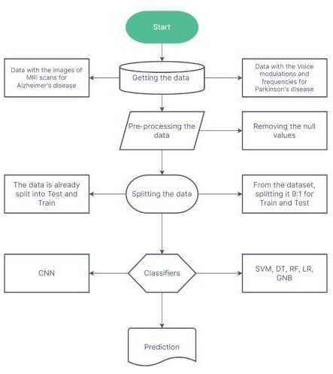

Figure 1. System Architecture

The model derived to detect Alzheimer is composed of multiple-level layers which is integrated into the architecture of the model. The network model that receives [R, G, B] colors images (176, 176, 3), since the last channel has 3 stand for the RGB channels. The bottom part starts with the Convolutional layers (Conv2D) with the ReLU activation function and max-pooling right at the beginning aspect. At this phase, the model extracts low-level features from the image. This is the base of the hierarchical structure of visual perception and it starts off with the immediate classification of geometric shapes and textures.

Y = f(W ∗ X + b) (1)

The stacking of three convolutional blocks in this layer at the conclusion is one of the noteworthy points. The two Conv2D layers involving the ReLu activation function, batch normalization and max-pooling are repeated in all blocks. Hierarchical representations are used for building high-feature extractors which are typically used by these blocks. Through dropout in going to regular to neural networks some of the neurons are randomly dropped out during training. This is introduced after some convolutional blocks so there is some control of overfitting which might happen. The Global Average Pooling layer is meant for capturing the global context at the imaging features level by shrinking the spatial dimensions of the feature maps to just a single vector in which each feature map is averaged.

In the suggested model three dense blocks are used for class and each dense block use ReLU activation layer, batch normalization and dropout layer. It is the last layers that constitute "voting" in the model and the classification is made based on the extracted features. Dense layer is an output layer of a network and the process is completed with activation layer. Batch normalization does for the most part this job. In the following equation , the activation functions are RELU (Rectified Linear Unit) and Swish.

Y = f(ReLU(W ∗ X + b). Swish(W ∗ X + b)) (2)

There is no need to specify the class activation map generation procedure because it is introduced to the model in the final layers. The last convolutional layer geared towards global average pooling will serve as the source of class activation map. The weights of this one serve as the array of feature’s significance between various classes. The CAM is computed as the weighted sum of the feature maps, which weight is class-specific gradients arising from the output layer derivatives regarding respective feature maps.

Bringing about fairness through the correction of inherit imbalance in the target variable (status) can be managed by this automation of RandomOverSampler method from the library of imbalanced-learn. It guarantees that both the sets of data used to train the model do not give one class of data higher priority. Next the Min-Max scaling algorithm is applied to normalize data inputs in order to ensure the high homogeneity of different features. The Principal Component Analysis (PCA) is subsequently employed for reducing dimensionality to save memory and time while maintaining 95% of the variance. Thus, the curse of dimensionality is eliminated.

One of the objective means of model training and evaluation is the division of the data set into the training and testing subsets to examine the performance of several ML algorithms. These algorithms cover Logistic Regression, Decision Tree, Random Forest, SVM, KNN, Gaussian Naive Bayes and Voting algorithm for ensemble. The precision scores, the confusion matrices, the classification reports and other performance measures are also one by one reported for each model so that we can evaluate the models on test set very meticulously.

Furthering, model features like an XGBoost classifier also has been separately trained and assessed alternatively. The classifier XGBoost is a featured gradient boosting model that ensures a higher accuracy score and a lower risk of overfitting.

# Experimentation and Results

The dataset we have used for the Alzheimer detection are the MRI images which contains four classes Demented, mild Demented, very mild Demented and non Demented.The figure2 below represents the images of the dataset.

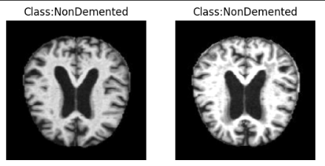

Figure 2: Dataset images

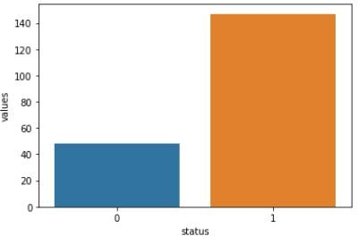The initial task is the comprehensible examination of the data set that consists of the recordings of individuals' voices, picking up the attributes related to the type of vocal quality. On the first inspection, there are no missing values and all the features selected are expressed correctly in the given data types. Data visualizations involving bar plots, distribution plots, box plots and correlation heat-map among the features serve the purpose of giving insights into the distribution, gap and correlation existed between the features. It is also essential to notice the bar diagram showing the lack of equal amount of data in both classes of the target variable. Hence this makes it important to address the class imbalance in the model training.

Figure 3: Frequency of unique value in target variable

Fig 3 bar graph reveals spread of the variable "status" as bars indicate frequencies of each unique value. This visualization help get the figure of classes whether the data has imbalance or not having balance provides a perception into the dataset or data compliance and potential class distributions concern.

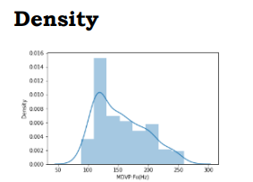

Figure 4 : Density Distribution of Dataframes

Figure 4, which is part of the DataFrame features, visualizes the distribution plots for each numeric column by developing graphs that can be used for the exploration and further analysis of the distribution characteristics of the data.

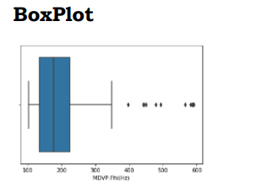

Figure 5:Boxplot of numerical column for visual exploration

In figure 5, effective boxplots are generated in the DataFrame all for the distribution characteristics’ the data is which further allows visual exploration and analysis.

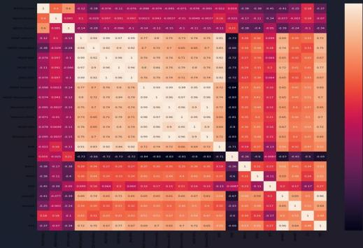

Figure 6: Heatmap comparison among features pairs

The resulting linear heatmap, as seen in figure 6, creates a linear representation of the strength and direction of the linear relationships between features in the dataset. Color shade shows the strength of the correlation between variables. Warmer color stands for positive correlation, and cooler color is a sign of strong negative correlation. Besides the numerical values are accounted for each cell that can offer the exact correlation coefficients that ease the perception of the heatmap. With this visualization you can look for possible collinearity relationships between features, and at the same time see what the general structure of the dataset is.

The Classification matrix for each model is provided for comparison of different models used in detecting parkinson’s disease respectively and the best suitable model for the detection is found.

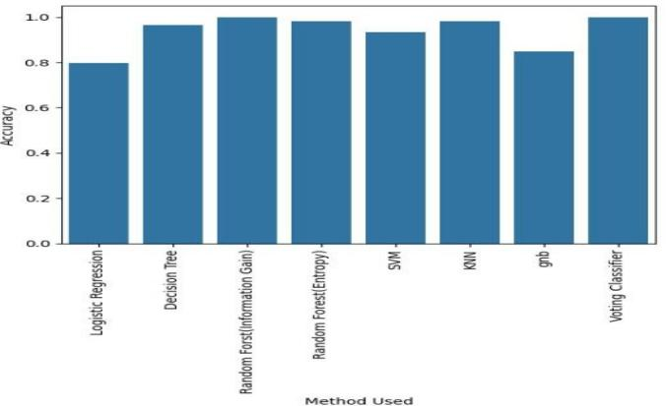

Figure 7: Models accuracy comparison

Figure 7 performance focuses on the classification models efficacy on the Parkinson's disease dataset. For the purpose of evaluation, widely applied classifiers including Logistic Regression, Decision Tree, Random Forest, Support Vector Machine (SVM), Gaussian Naive Bayes (GNB), K- Nearest Neighbors (KNN), and a Voting Classifier are trained and the common performance metrics such as accuracy are used to compare the results.

Table 1: Comparative analysis of model

|  |  |  |  |  |
| --- | --- | --- | --- | --- |
| **Method Used** | **Accuracy** | **Precision** | **Recall** | **F1-Score** |
| Logistic Regression | 0.796 | 0.828 | 0.828 | 0.828 |
| Decision Tree | 0.966 | 1.000 | 0.942 | 0.970 |
| Random Forest (Information Gain) | 1.000 | 1.000 | 1.000 | 1.000 |
| Random Forest (Entropy) | 0.983 | 1.000 | 0.971 | 0.985 |
| SVM | 0.932 | 1.000 | 0.885 | 0.939 |
| KNN | 0.983 | 0.882 | 0.857 | 0.869 |
| gnb | 0.847 | 1.000 | 0.971 | 0.985 |
| Voting Classifier | 1.000 | 1.000 | 1.000 | 1.000 |

The model provides an understanding of this and other classification algorithms performed by the data set Parkinson. Logistic Regression, being a linear classification method, demonstrated a moderate accuracy of 79.66%, thereby, causing the discrimination between the disease and non- disease instances occur, whereby, some limitations to capturing complex patterns were also observed. Instead, the Decision tree family of models with the Random Forest model using the Information Gain and Entropy criteria both showed aggregate accuracy rates of 96.61% and 98.31% respectively. It is stipulated that this kind of ensembles is competent in depiction of the intricate relations inside the data set which in general yields better classification performance.

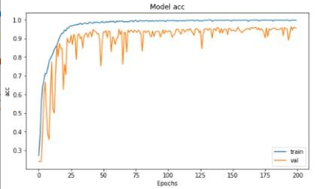

Figure 8: Model accuracy vs epoch of CNN-CAM model

Figure 8 presents model accuracy over epochs, in which the resultant graph shows how the algorithm performance improves with passing training iterations. At first, the accuracy will rapidly increase,which corresponds to fast learning. However, it will involve no improvement later Tracking down this tendency allows to make adjustments in training algorithms and also to avoid overfitting problems.

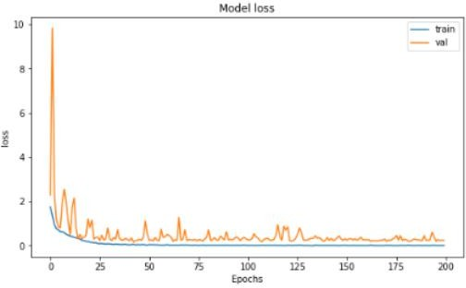

Figure 9: Model loss vs epoch of CNN-CAM model

Figure 9 presents the model's loss for evaluation. training and testing set epochs graph, where you are able to clearly see the convergence of the network during training. And the longer epochs, the lower the loss, they normally show indicating more efficient model. There could be ups and downs due to training adjustments. However, the tendency is an overall downward trend following it indicates good learning with potential accuracy of the diagnosing.

Initially we were using CNN model for alzheimer disease prediction and the accuracy we get as 66% and after integrating class activation map in the model the accuracyof the model is increased to 75%. this improvement in the model is because now after using CAM model is focussing on relevant features in the MRI scan which leads to more accurate prediction of the disease.

# Conclusion

This research has shown a breakthrough as they were able to diagnose and predict Parkinson’s only with vocal biomarker as the feature which has advanced the machine learning mechanism that does this solely relying on these features. Next, the authors aimed to check the exactitude of the machine learning classifiers to cut down the set of features and leave the optimal and efficient ones. Therefore they noted that the conceptual level accuracy was accomplished based on the fact that the sorted features were correctly applied in the "dirty" and high dimensional data. These features reveal the essence of the voice among the tools in health monitoring; also, deep understand about neuropsychiatric diseases is necessary. Consequently, these technologies must be able to develop the highly improved feature lines so as to be even pushing them to include the video description and even media which can be eventually used for detailed diagnosis using the short audio clips.The second part of research applied the Convolutional Neural Network integrated with CAM in the brain MRI image classification task indicated that brain MRI scans from the patients with Alzheimer’s can be distinguished from the healthy controls’ scans. If these factors are taken into thought, the treatment approach in the hospitals and devoted healthcare centers may be altered.

# Future Enhancements

There are many paths that can be explored in the future to make this project more efficacious and robust. Firstly, including more heterogeneous data sets for both Alzheimer's and Parkinson's disease would enrich the knowledge base of predictive model generalizability among different age groups and health states. Additionally, investigate advanced aspects of deep learning including transfer learning and attention mechanisms can enhance the accuracy of Alzheimer's disease prediction model and strongly present high quality diagnosis. Besides that, the effort of checking out ensemble learning methods that bring together several classifiers, like stacking or boosting algorithms, may bring another big improvement to the models. Additionally, a longitudinal study to monitor disease progression and the incorporation of multi-modal data, such as genetic and biomarkers, can be integrated into disease prediction and prognosis to improve the whole approach. Last but not least, teaming up with medical professionals and institutions for the clinical and ethical validation of the models' outcomes will constitute the milestone upon which the real-world implementation and impact hinge.

# Limitations

However, these system based on CNNs and SVM overcomes some of the obstacles, but certain limitations preventing the effectiveness. The concerns of the model's narrow scope in terms of species and environmental conditions and the inadequate representation of what is included in the data for training that may give rise to errors or bias is another issue concerning the model. Moreover, the system performance will be dictated by the effectiveness of the training dataset that might not be available from different sources. Notably, too, throughout both the training and inference stages, the computer complexity has a burdensome scaling dimension. In addition to the fact that the interpretations made by CNNs and SVMs are unclear when it comes to making decisions, which will also hinder trust building; there is another problem of external factors like lighting or occlusion which will make their identification also impaired. A second problem is about that many users misunderstand the information since people have different levels of understanding. Therefore some of issues such as data quality and diversity, optimization of algorithm for representation and interpretability, robustness enhancement to adapt to the mixture of environmental situations are still present. Additionally, functions and techniques that the user can benefit from such as explicit instructions and feedback must be introduced to the interface. Regular investigation and development process really matters for the gaining of the solutions that can be used to advance the usability of plant species identification software.

##### References

1. Vaiciukynas, E., Verikas, A., Gelzinis, A., & Bacauskiene, M. (2017). Detecting Parkinson’s disease from sustained phonation and speech signals. Frontiers in Neurology, 8. DOI: 10.3389
2. Jo, T., Nho, K., & Saykin, A. J. (2019). Deep learning in Alzheimer's disease: Diagnostic classification and prognostic prediction using neuroimaging data.
3. K.S.Biju, S.S.Alfa, Kavya Lal, Alvia Antony, M Kurup Akhil. (2017). Alzheimer’s detection based on segmentation of an MRI image.
4. Shankar, K., Lakshmanaprabu, S. K., Khanna, A., Tanwar, S., Rodrigues, J. J. P., & Roy, N. R. (2019). Alzheimer detection using group grey wolf optimization based features with convolutional classifier.
5. Jefferson S. Almeida, Pedro P. Reboucas Filho, Tiego Carneiro, Wei Wei, Robertas Damsevicius, Rytis Maskeliuna, Victor Hugo C.de Albuquerque. (2019). Detecting Parkinson’s disease with sustained phonation and speech signals using machine learning techniques.
6. Oh, S. L., Hagiwara, Y., Raghavendra, U., Yuvaraj, R., Arunkumar, N., Murugappan, M., & Acharya, U. R. (2018). A deep learning approach for Parkinson’s disease diagnosis from EEG signals.
7. Rezaei, M., Zereshki, E., Shahsavari, S., Salehi, M. G., & Sharini, H. (2020). Prediction of Alzheimer’s Disease Using Machine Learning Classifiers.
8. Sa, B. K., Sa, A. S., Lala, K., Antonya, A., & Kurupa, A. M. (2017). Alzheimer's detection based on segmentation of MRI image.
9. Al-Otaibi, S., Ayouni, S., Khan, M. M. H., & Badr, M. (2023). *Retracted A novel method for Parkinson’s disease diagnosis utilizing treatment protocols.*
10. W., Rajesh, A., & Lakshmi, M. M. (2022). Diagnosis of Parkinson’s Disease Using EEG and fMRI.
11. Rastegar, D. A., Ho, N., Halliday, G. M., & Dzamko, N. (2019). Parkinson’s progression prediction using machine learning and serum cytokines.
12. Gramotnev, G., Gramotnev, D. K., & Gramotnev, A. (2019). Parkinson’s disease prognostic scores for progression of cognitive decline.